MODEL 1: **SIMPLE LINEAR REGRESSION MODEL**

As initial step will import the required libraries and describe the data. Then plotted scatter plots for all the features that are Height, Width, Signed, Picture and House with respect to Price.

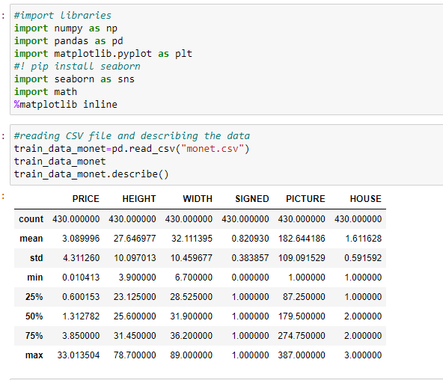

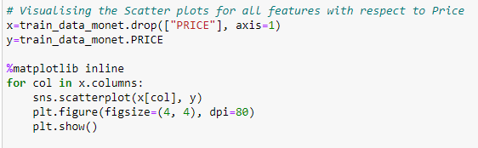

Now without splitting the data into train and test sets, applying linear regression we get slope and intercept values as slope=0.13432083933042452, intercept=-0.6235688584370997.

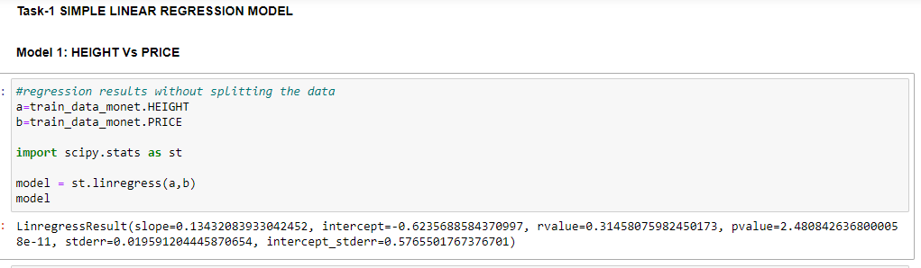

Plotting the graph between Height and Price to see the relation between the variables.

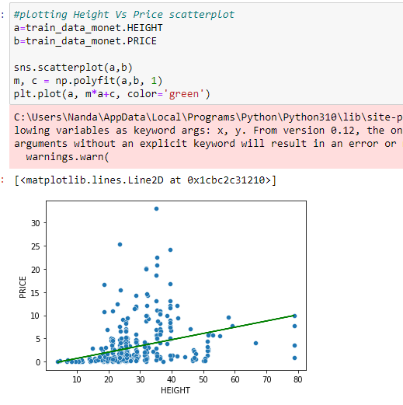

Considered Height as independent variable and Price as dependent variable. So, defined variables as

considered. With help of train_test_split splitted the data into train and test sets. Then applied linear regression to predict the price values based on test data.

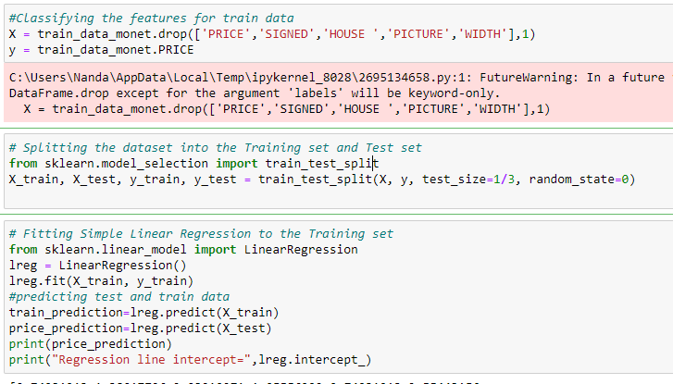



Now visualising the train and test data

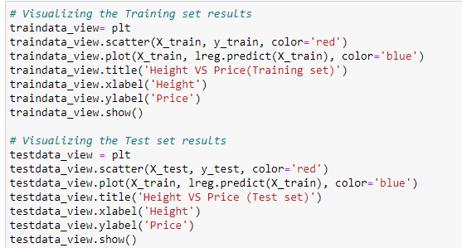

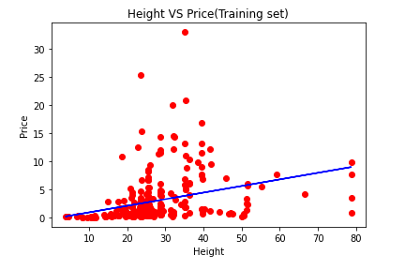

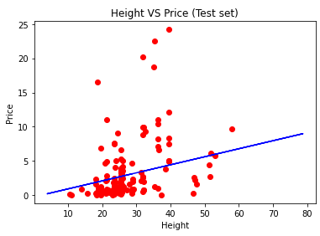

From graphs we can say that our model covers few of the data and test data fits the model much like the train data.

Finding the error values:

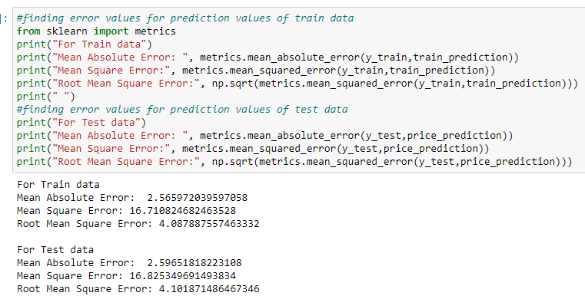

MODEL 2: SIZE Vs PRICE Simple Linear Regression Model

In dataset there is no SIZE feature, so created it by using Height and Width features. Size=Height*Width.

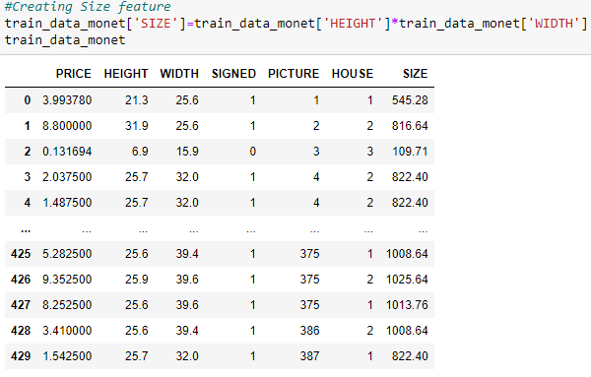

Relationship between Size and Price:

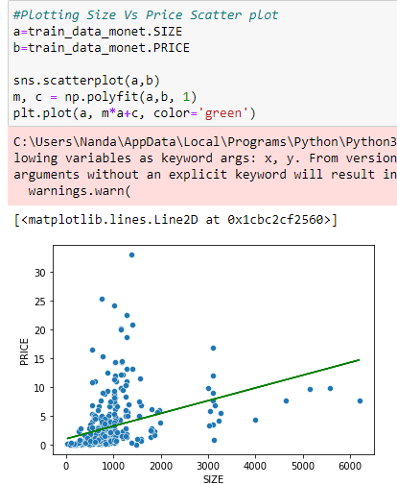

Splitting the data and applying linear regression to predict the price based on test data and calculating the error values.

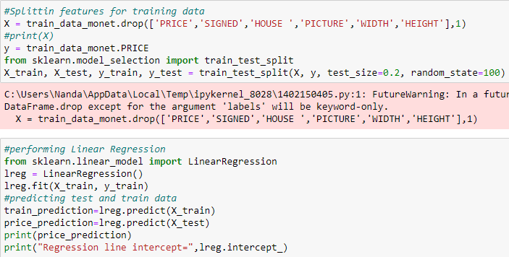



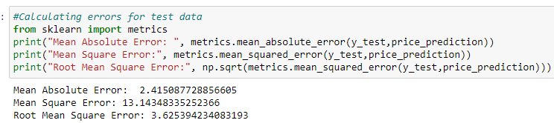

MODEL 3: **Multivariate Linear Regression Model**

**Considered Signed, Picture, House and Size as independent values and price as independent and predict value.**

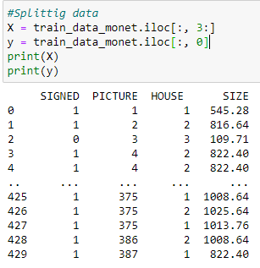

Performing Normalisation using MinMaxScaler to improve model accuracy.

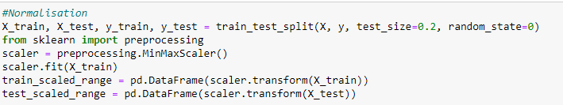

Now performing linear regression and calculating accuracy, error values.

